

Course: English II

UNIT 1: “USED TO” vs. “WOULD” FOR HABITS AND STATES IN THE PAST

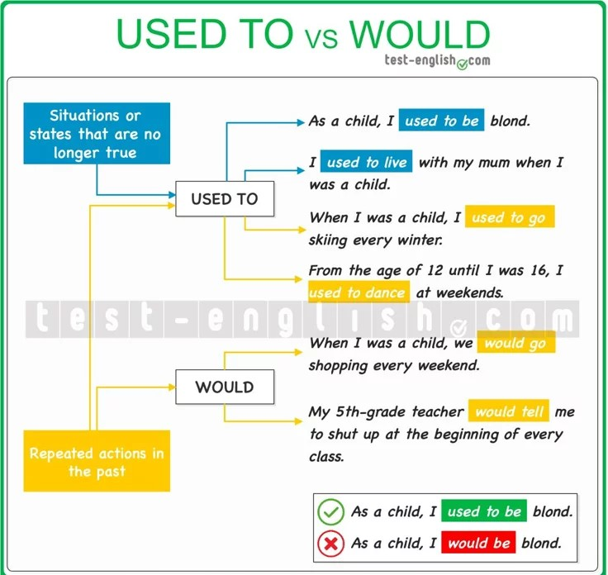

“USED TO”

a) We can use “used to + infinitive” to talk about things that we did repeatedly in the past.
- When I was a child, I used to go skiing every winter.
- From the age of 12 until I was 16, I used to dance at weekends.

b) We can use “used to + infinitive” to talk about situations or states (stative verbs) which were true in the past but are no longer true.
- As a child, I used to be blond.
- I used to live with my mum when I was a child.

“WOULD”
a) We can also use “would + infinitive” to talk about things that we did repeatedly in the past.
- When I was a child, we would go to the shopping centre every Saturday. (go=action verb)
- My 5th-grade teacher would tell me to shut up at the beginning of every class.(tell=action verb)

Note: we can’t use “would” to talk about situations or states (stative verbs) that are no longer true.
- I would be blond as a child. (be=stative verb)
- I used to be blond as a child.
- I would live with my mum when I was a child. (live=stative verb)
- I used to live with my mum when I was a child.

Nota: para poder utilizar “used to” and “would” de forma adecuada deben tener en cuenta la diferencia entre Stative Verbs y Active Verbs
Veamos: en inglés, algunos verbos describen estados o situaciones (stative verbs) y otros describen acciones (active or dynamic verbs)

1. STATIVE VERBS (verbos estáticos). Estos verbos hablan de:
- emociones
- pensamientos
- gustos
- posesión
- sentidos
- estados en general
NO muestran una acción física o un movimiento. Por eso, generalmente, no se usan en los tiempos continuos (- ing ).
Examples:
- I love music.
- She knows the answer.
- They have a car.
- We believe you.
Incorrect:
- I am loving music.
- She is knowing the answer.

Examples of stative verbs:
Agree / appear (parece) / believe / belong / disagree / dislike / forget / hate / have / hear / hope / know / like / love / need / own / realize / remember / see / seem / smell / taste / think / understand / want / wish, etc.
Si bien, generalmente, estos verbos NO se usan en los tiempos continuos (- ing ) SI existen algunas excepciones. Es decir, hay verbos que se pueden usar en tiempos simples o continuos pero su significado varía según se use de una manera u otra. Por ejemplo, el verbo “think”, el verbo “have” y el verbo “to be”.

a) “THINK” en tiempo simple. Cuando usamos “think” en presente simple, generalmente significa “opinar” o “creer”.
I think this exercise is difficult. (Creo / Opino que este ejercicio es difícil.)
Acá “think” es un stative verb porque habla de una opinión o estado mental.

b) “THINK” en tiempo continuo. Cuando usamos “think” en presente continuo, cambia el significado a “estar pensando / considerando” en ese momento.
I am thinking about the crime scene.(Estoy pensando en la escena del crimen.)
Acá “think” es un active verb porque describe una acción mental en progreso.

a) HAVE present simple = posesión
- She has a camera. (Ella tiene una cámara.)
Acá “have” está actuando como stative verb, es decir, indica estado / posesión → no continuous.

b) HAVE present continuous = actividad
- She is having lunch. (Ella está almorzando.)
Acá “have” está actuando como un active verb, es decir, indica una acción en progreso.
a) BE present simple
* He is inmature. (El es siempre inmaduro)
b) BE present continuous
* He is being inmature. (El está siendo o actuando de forma inmadura temporalmente)

2. ACTIVE VERBS (verbos de acción). Estos verbos describen acciones o actividades. Estas acciones sí pueden estar ocurriendo “ahora”, por eso pueden usarse en presente continuo.

Examples:
- He is running.
- They are studying.
- I am eating pizza.
- The dog is sleeping.

Examples of active verbs: collect / dance / drink / drive / eat / play / run / speak / study / walk / work / write / swim, etc.

Truco fácil para reconocerlos. Deben preguntarse:

¿Hay una acción visible?
- Sí → probablemente es un active verb
- No → probablemente es un stative verb

Ejemplos: “run” → podemos verlo → active verb

“know” → no podemos verlo físicamente → stative verb

Source for this worksheet:
https://test-english.com/explanation/b1-2/used-past-habits-repeated-actions/

